Quality Enhancement for RenTrip

1. When editing booking, the refund reason field shall be replaced with a dropdown of reasons. These reasons can be added by Admin dashboard > Settings.

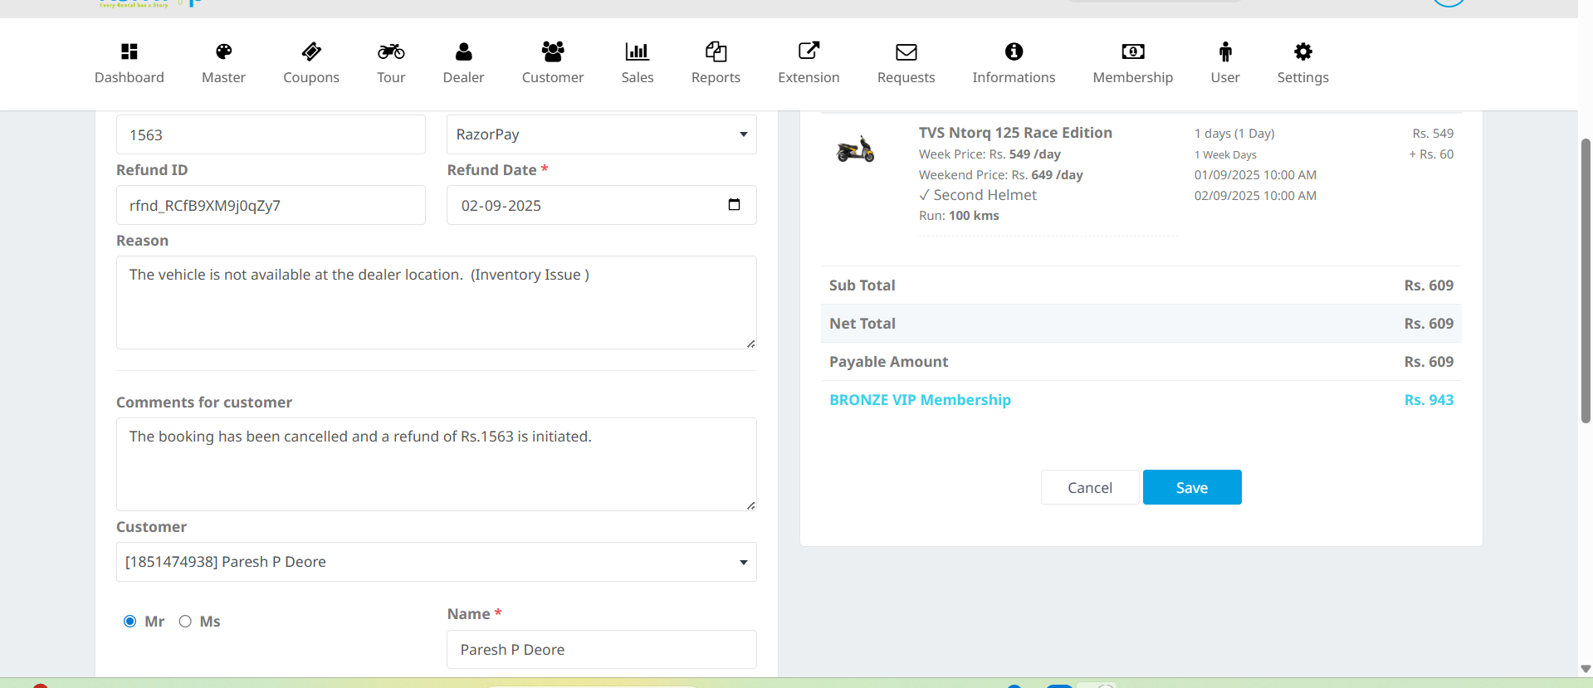

2. Option to select Booking Status shall not available. Booking Status shall be associated with Reasons, filled in Settings.

For Example, in settings –

Reason | Booking Status
Vehicle not available at location | Full Refund
Customer requested to cancel booking | Cancelled with Refund

Once support executive shall select the reason for cancellation, booking status shall be automatically applied.

